# Lab 2 - Launching an Amazon Redshift Cluster

Objs -

1. Create an IAM role for loading data into Amazon Redshift
2. Create a VPC
3. Create a security group
4. Create a cluster subnet group
5. Create and configure a cluster parameter group
6. Launch an Amazon Redshift cluster
7. Run queries against the database in your Amazon Redshift cluster

**Task 1: Creating an IAM role**

1.1 Open IAM in console

1.2 select create role

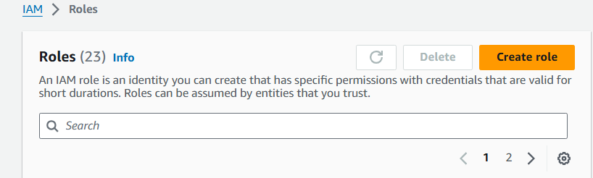

1.3 select redshift in use case

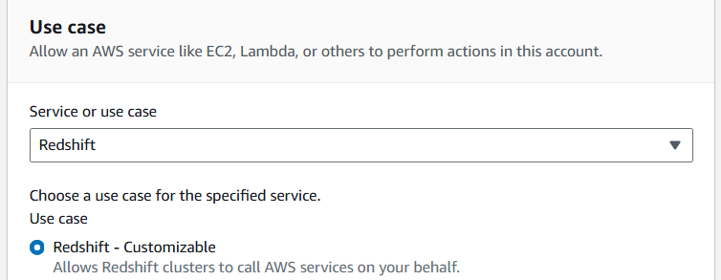

1.4 select **AmazonS3ReadOnlyAccess**

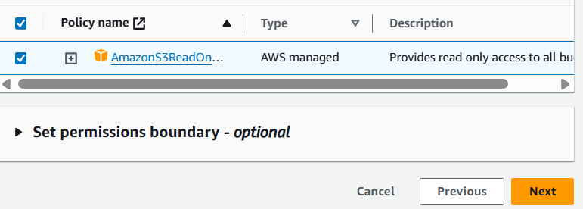

1.5 enter the role name

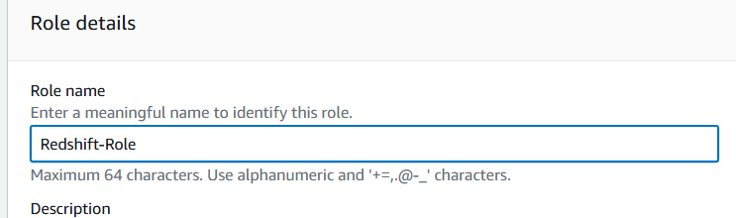

1.6 create role

This role permits the Amazon Redshift cluster to read data from Amazon S3

**Task 2: Creating a VPC**

2.1 open VPC and select create VPC

2.2 use following

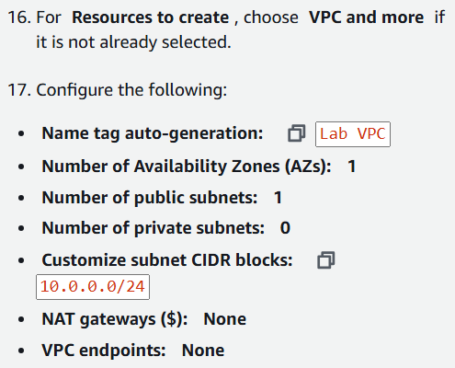

2.3 this creates:

* A VPC with an IP address range of 10.0.0.0/16
  + A single public subnet with an IP address range of 10.0.0.0/24
  + An internet gateway that links the VPC to the internet
  + A public route table linking the internet gateway to the public subnet

2.4 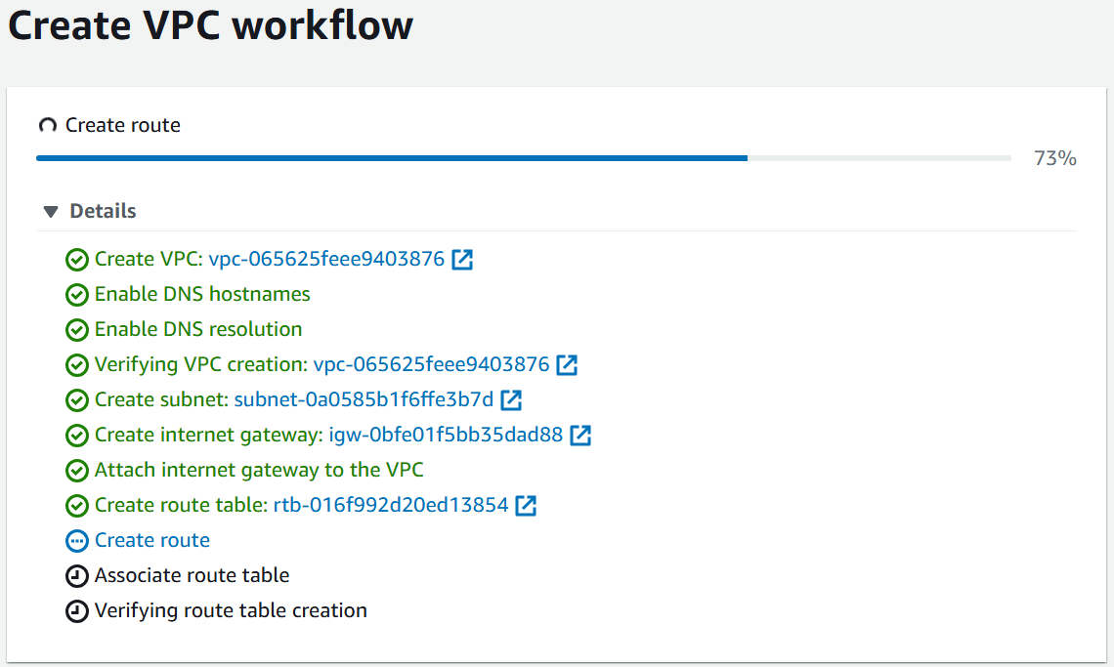

2.5 view VPC

**Task 3: Creating a VPC security group**

A security group acts as a firewall for resources in a VPC, controlling both inbound and outbound traffic at the resource level.

We configure a VPC security group to permit client connections to the Amazon Redshift cluster endpoint. The security group will permit access to Amazon Redshift, which runs on port 5439.

3.1 go to security groups, select create

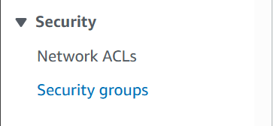

3.2 use this

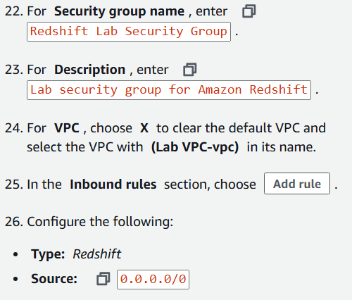

3.3 A source of 0.0.0.0/0 permits access from the entire internet. Only for this lab

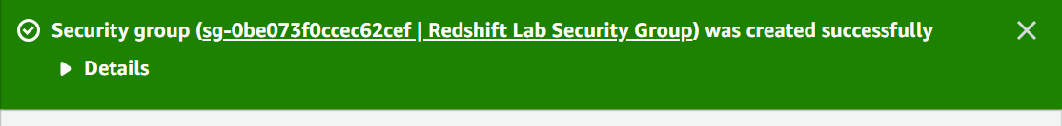

**Task 4: Creating a cluster subnet group**

Your VPC can have multiple subnets that group resources based on security and operational needs. A cluster subnet group allows you to specify a set of subnets in your VPC. When provisioning an Amazon Redshift cluster, you select the subnet group, and Amazon Redshift creates the cluster in one of the subnets listed in the cluster subnet group.

4.1 open redshift and select

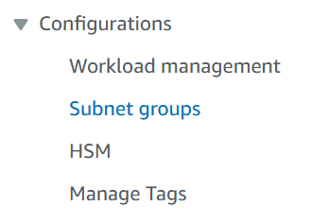

4.2 create subnet grp as follows;

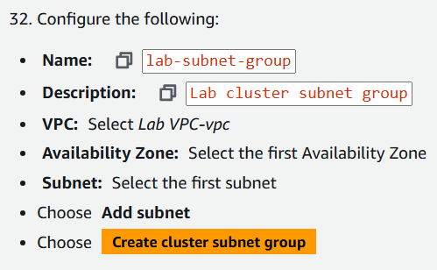



4.3 The cluster subnet group is created. This tells Amazon Redshift which subnet(s), in which Availability Zone(s), can be used when launching the cluster.

‘

**Task 5: Creating a cluster parameter group**

It is associated with each cluster. The parameter group is a group of settings that apply to all of the databases that you create in the cluster. The parameter group includes settings such as query timeout and date style.

5.1 choose this

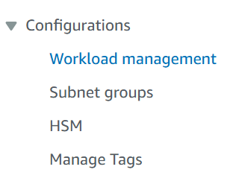

5.2 create

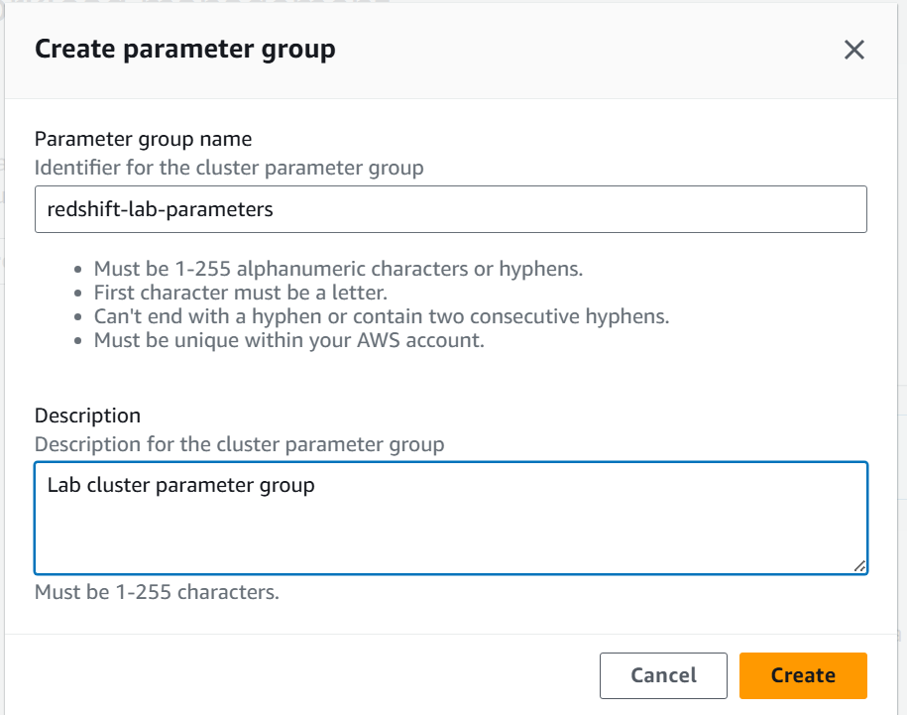

5.3 edit the parameters

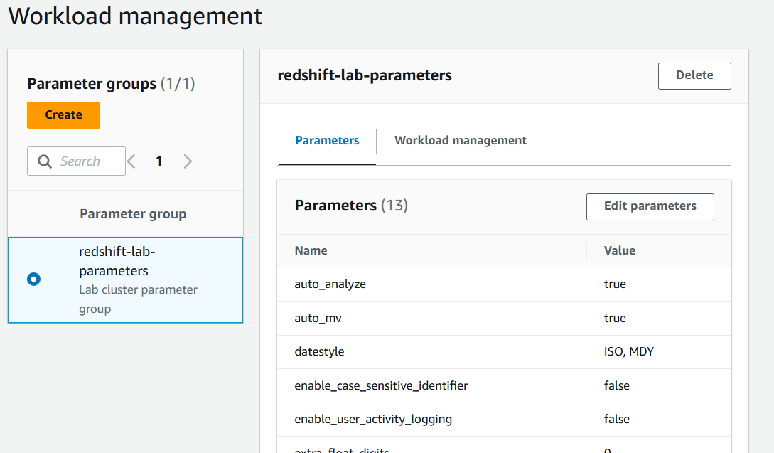

5.4 using these values

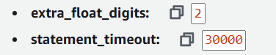

Only 2 changes from default

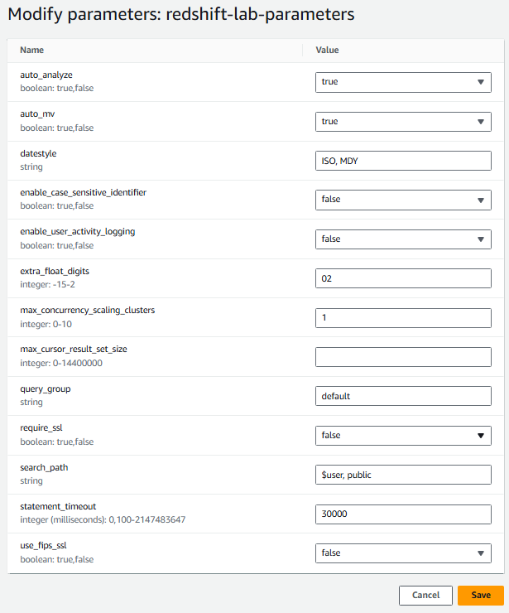

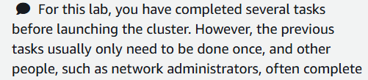

**Task 6: Launching an Amazon Redshift cluster**

6.1 select

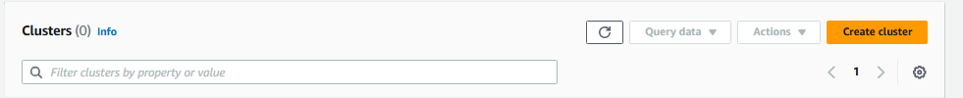

6.2 use

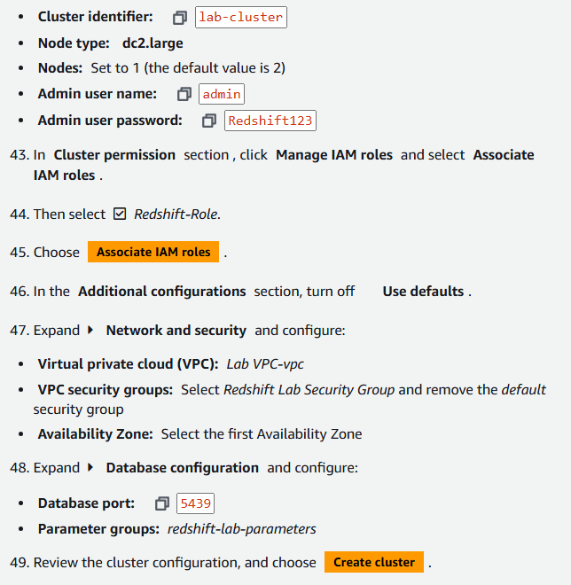

6.3 creating

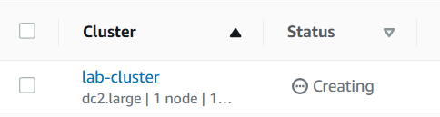

6.4 select the cluster and in actions, choose

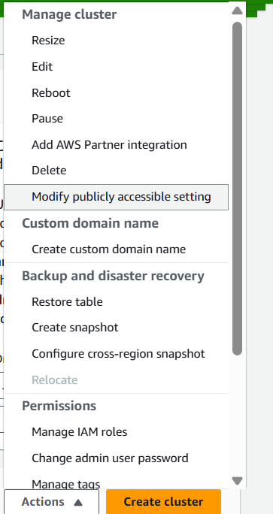

6.5 turn on public accessible

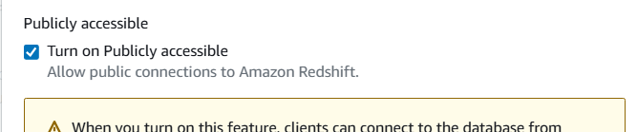

**Task 7: Connecting to the Amazon Redshift cluster**

**We use postgresql for this**

7.1 open given url

Fill these

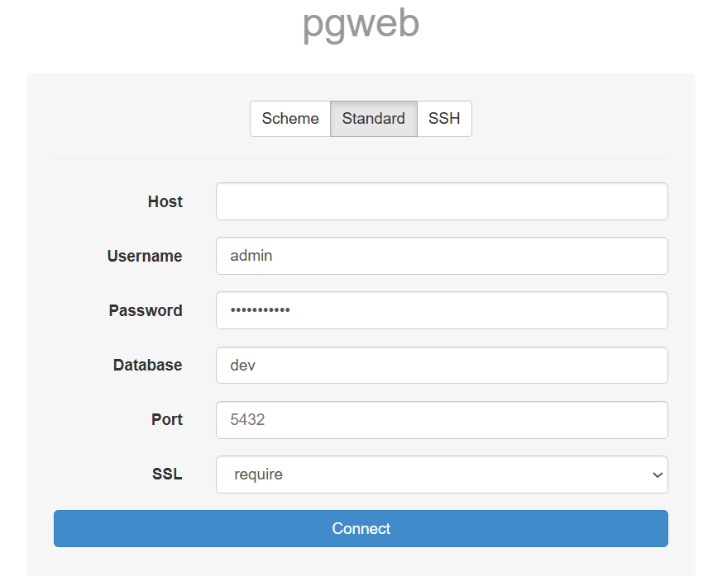

7.2 for host value

Go to cluster, and copy endpoint value

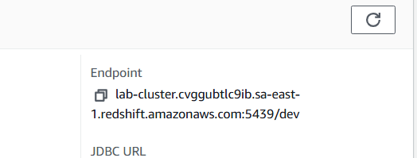

7.3 connect

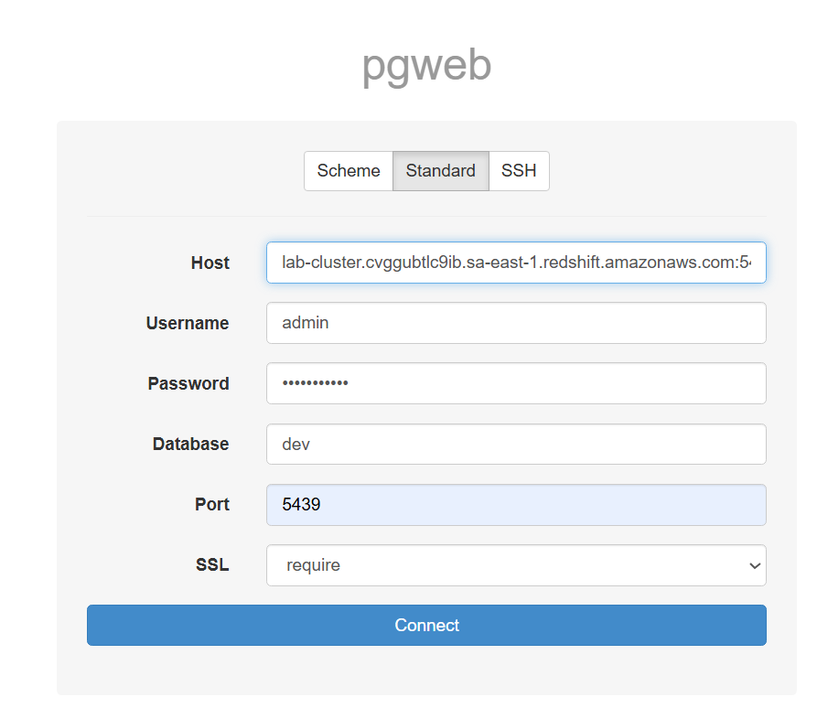

**Task 8: Running queries**

8.1 we can now run queries in postgresql interface.